**TECHNOLOGY NAME : SMART PARKING**

**INTRODUCTION:-**

In smart cities, there is a greater need for new and effective technology to tackle many of the problems that are visible on the surface, as well as to make cities less crowded. Finding a parking spot is one of the most aggravating issues for drivers. Particularly in public venues such as shopping malls, 5-star hotels, and multiplex cinema halls. Even within the park, drivers waste time and fuel hunting for a spot to park their cars. This will damage the driver's emotions as well as pollute the environment while searching for a parking spot. In this study, we create and design a smart parking system that effectively addresses these issues.

The system lacks a payment mechanism as well as guide technology that can automatically find available parking spaces. The goal of the smart auto parking initiative is to make parking simple and straightforward. This project assists car drivers in parking their vehicles with the least amount of wasted time by providing reliable information on the availability of parking spaces. The servo motors, LCD display, and IR sensor are all connected to an Arduino Uno microcontroller unit. The LCD shows how much space is available, and the IR sensors keep track of how many automobiles enter and exit the parking place. The IR sensors identify whether or not a parking place is available.

**OVERVIEW OF THE PROJECT:-**

It's a project that uses an Arduino microcontroller. It employs an infrared sensor to detect the vacancy of each parking space at a car park level, then sends a wireless signal to a microprocessor, which processes and shows the total number of available parking slots on 16x2 LCD displays.

Currently, the majority of current parking lots lack a well-organized framework. The majority of them are run by hand and are inefficient. The issue that constantly arises in the car park is the time spent looking for available parking spaces. Users will continue to circle the parking lot until they find a vacant spot. This problem is most common in urban locations, where the number of automobiles exceeds the number of parking places available.

These ineffective situations occurred as a result of a lack of implementation in already accessible technologies. To provide space for car drivers, many local car parks are now developed inside retail malls or multipurpose buildings.

Knowing how difficult it may be to obtain a parking spot in some regions, this project was created to address the issue. The project's main goal is to figure out the best way to direct drivers and vehicle users to a free parking lot in a short amount of time.

**OBJECTIVE:-**

The system utilizes an Arduino Uno board along with an ultrasonic sensor, IR sensor, servo motor, and object counter to efficiently park vehicles. This prototype aims to optimize parking space utilization, reduce human error, and enhance overall parking efficiency.

The basic objective of a smart parking solution is to identify a vehicle’s presence or absence in a particular parking space with a high degree of accuracy, and to pass on this data into a system for visualization and analysis – to be available for parking asset managers and/or enforcement officers.

* Accuracy of detecting a vehicle presence/absence
* Total cost of solute
* Privacy concerns

The laser scanner sensors are well known for their accuracy of detecting a vehicle presence – therefore the sensor located at the entrance and exit of a parking area will count with high accuracy the entrance and exit of the vehicles, taking into consideration even two cars stopping very close to each other.

**BLOCK DIAGRAM:-**

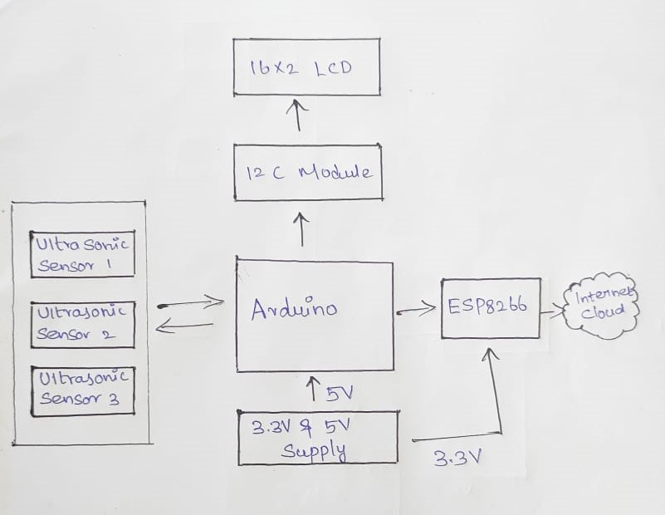

**FLOW CHART:**

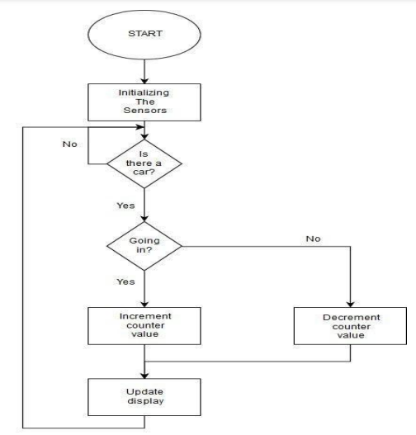

**RESULTS:-**

The IoT-based Car Parking Management System with IR sensor was able to identify the presence or absence of a car, show the availability status of parking slots, and save the IR sensor data into a database. Furthermore, the suggested parking system has the advantage of being able to show the user the actual position of a parking place. According to the findings, the proposed car parking system with IR sensor was a good idea and a great system to develop, and it indicates that the respondents positively accepted the proposed parking system in order to minimise and reduce the problem of vehicle parking, particularly the time spent looking for available parking spaces.